|  |  |
| --- | --- |
| **[Assignment / Project] – External Document** |  |
| <Course Code>  <Couse Name> |
| [Odd / Even / Compact] Semester Year 9999/9999 |

* Project Title

PaiCakery

* Introduction

PaiCakery is a cake shop that has been famous since 1998 until now for its cupcakes in indonesia. With more than 20 branch spread all over Indonesia, PaiCakery taking pride in the baking process, the ingredients, the presentation, and the delivery to the customers. They will strive to go the Extra Mile for customer satisfaction, superior quality of products, creative package designs, value and affordability.

To grow its business even larger, PaiCakery also started to advertise and sell their cakes online through the website. Recently they added a new kind of cake to the menu, cupcakes! To make people know about this new product of PaiCakery, their marketing department decided to spread an interactive online advertisement that advertised their cupcakes and also add link to their website to order the cupcakes.

* Report / Documentation

1. Opening

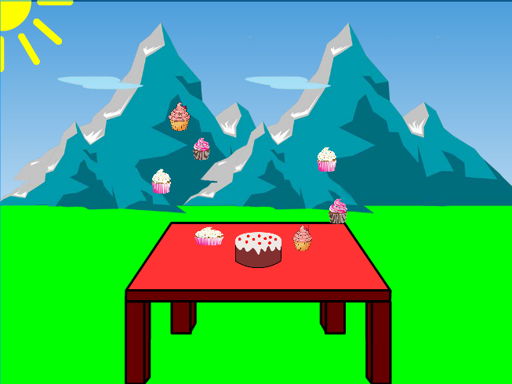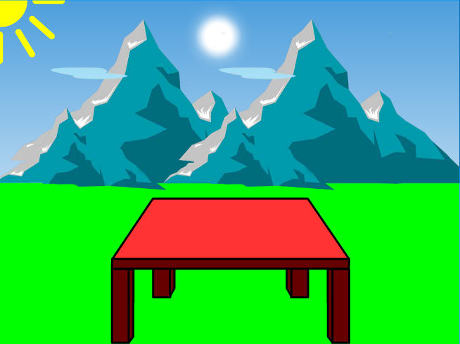

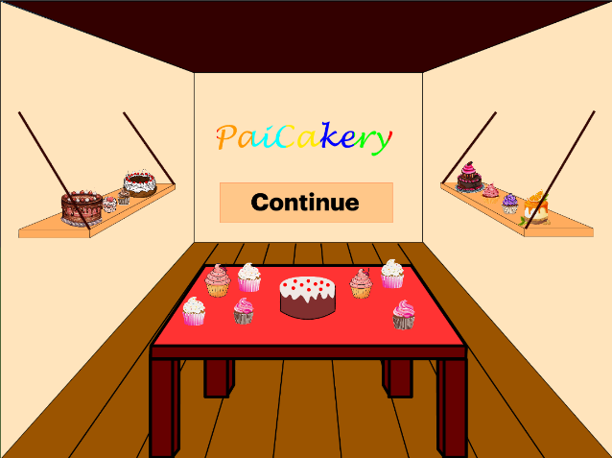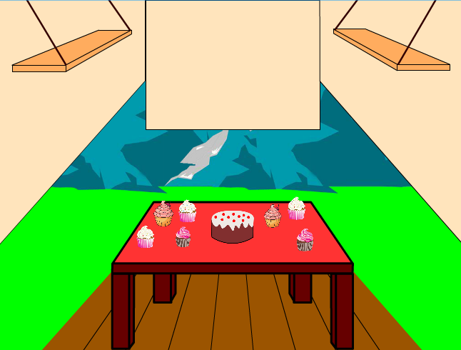

In the opening, in the fairy mountain, there is some animation of one big cake and some cupcakes that were given by a fairy fell down to the table and then entered the cake shop. At the end of the opening, the magic cakes, **PaiCakery’s logo**, and a **continue button** will appear in a shop. Continue button will redirect user to the main menu section.

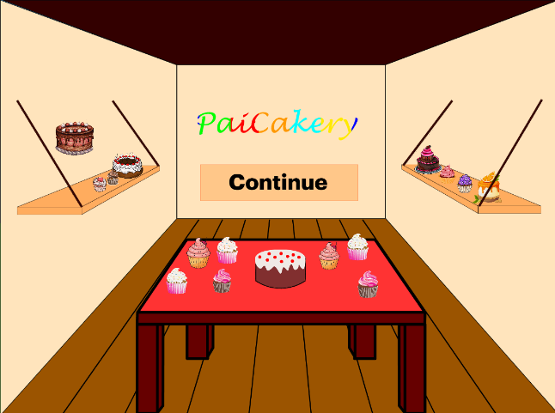

If user hover their cursor to one of the magic cakes on the hanging shelves, the “magic” animation in that cake will activate.

1. Main Menu

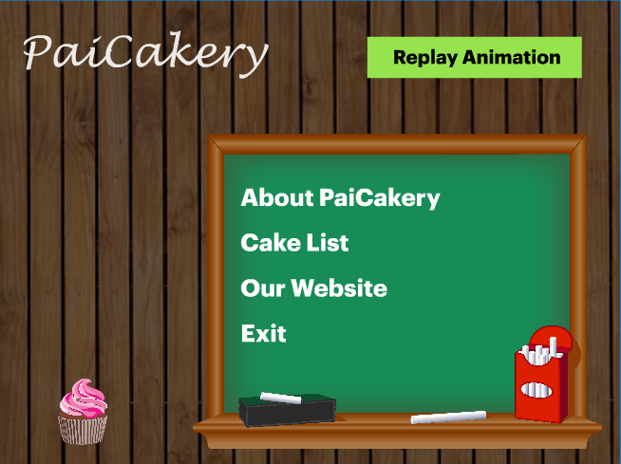

When user enter the main menu, the background music will be played. The main menu will show a **replay button** to replay the opening animation, an **about button** to show PaiCakery’s promotion video, a **cake list button** to show PaiCakery’s cupcakes menu, our website button that will open a new tab, then redirect people to the PaiCakery’s website to make orders, lastly the **exit button** that will trigger the closing and bring people to the end of this advertisement. The main menu is also decorated with cake images that continuously change.

1. About PaiCakery Menu

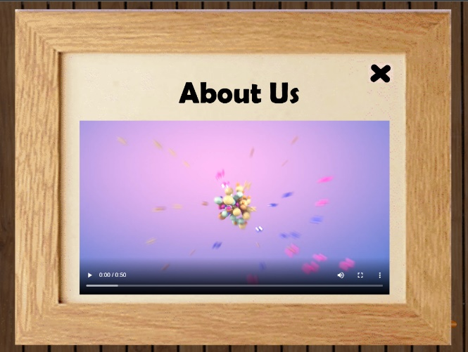

About Us modal will show after people press the about button in the main menu. This modal will show a promotion video about the cake shop. This modal also has a close button to bring people back to the main menu. While people see this modal, the background music will be paused and then played again after people back to the main menu.

1. Cake List Menu

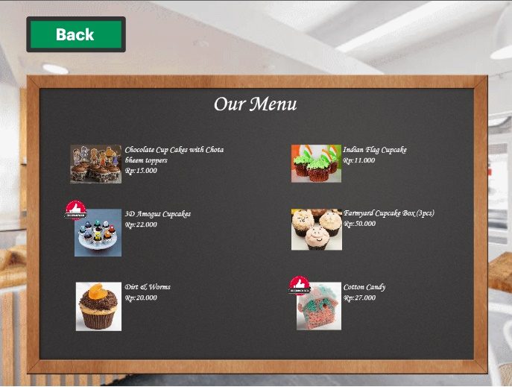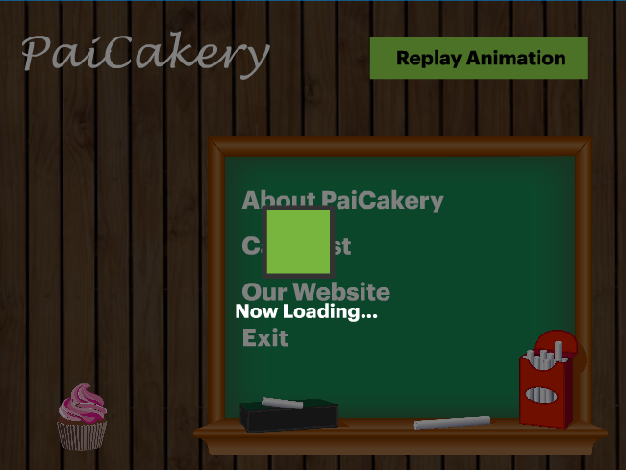

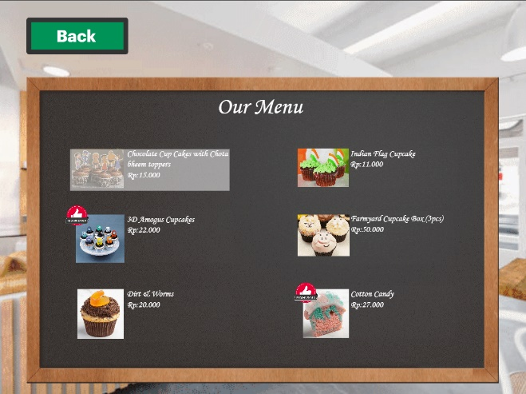

After clicking the cake list button in the main menu, the screen will load and get user into the menu page, this page shows them the clickable PaiCakery’s cupcakes menu and for the menu that is recommended, there will be a thumb stamp on the top left of the picture. When people hover to one of the menus, the area around that menu will change color to show that menu is clickable. To see the description and the detail of each cupcake, people can click the menu and then the screen will be directed to the cake detail page. The back button in top left of the page, will get people back to the main menu.

1. Menu Detail

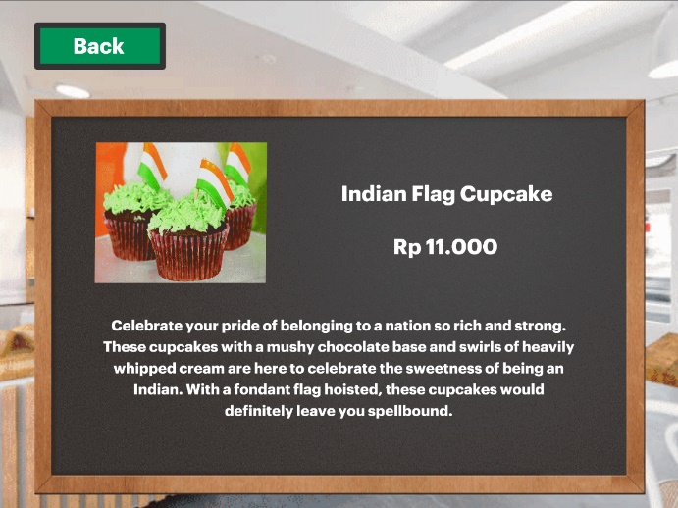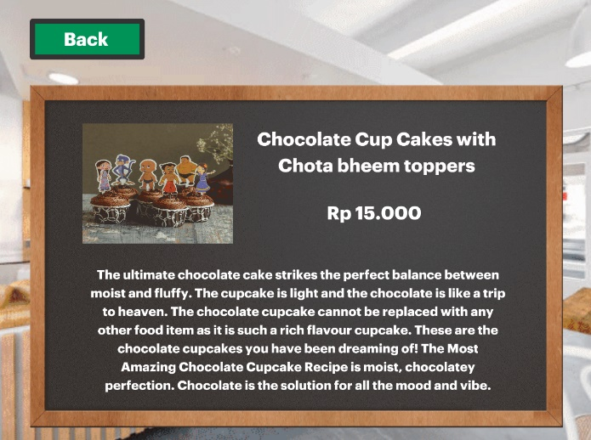

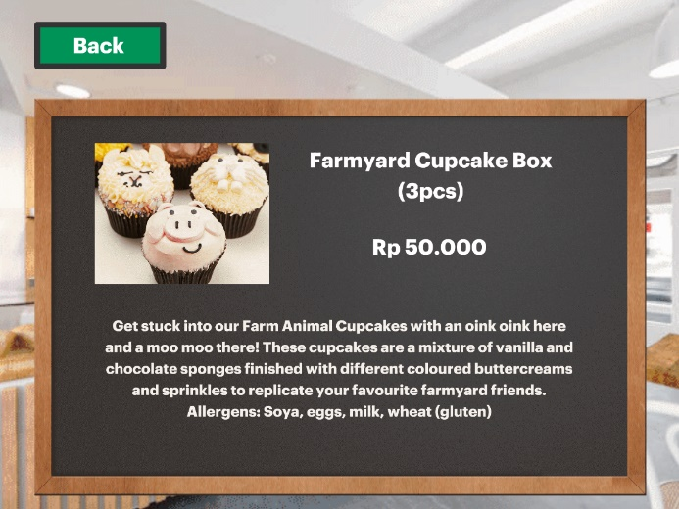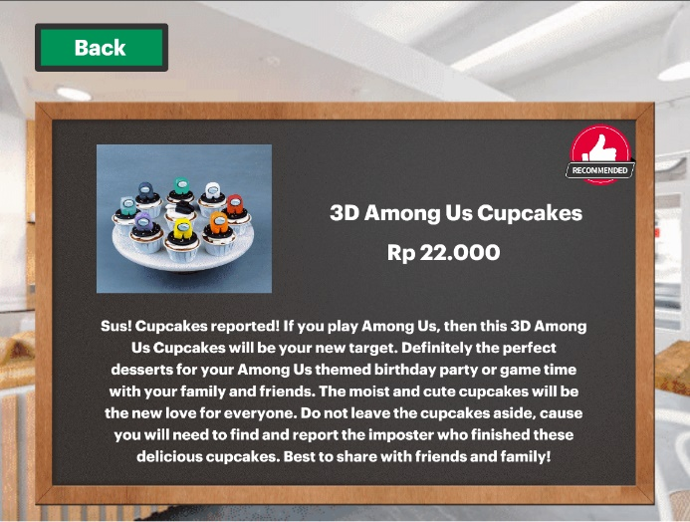

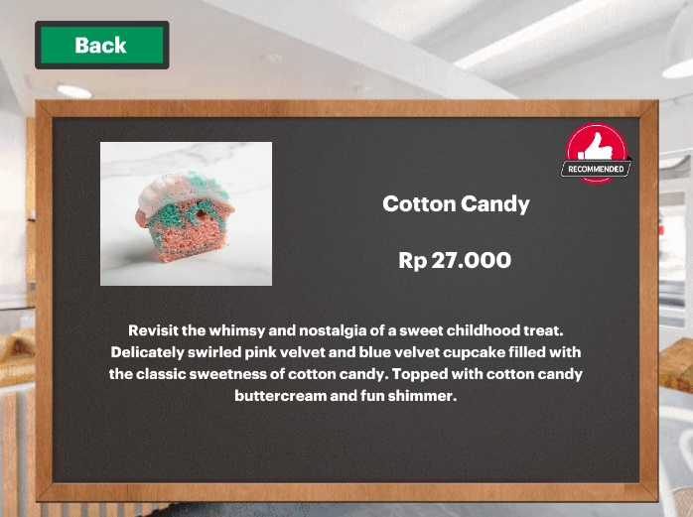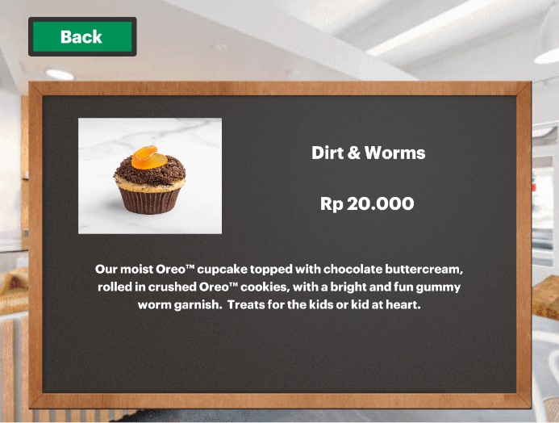

After clicking one menu, people will be directed to one of these screens according to the menu that they click. This menu detail will display the cake’s picture, name, price, and brief description. There will be a back button on the top left that will redirect people back to the cake list page.

1. Closing

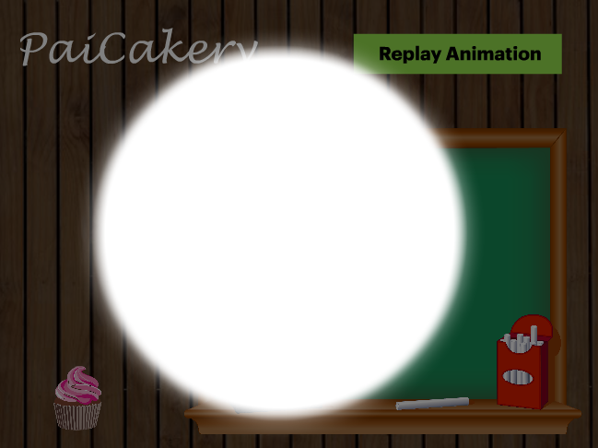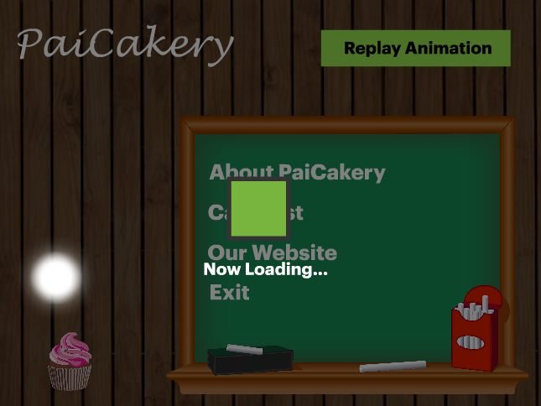



When user click the exit button in the main menu, it will call the fairy to take her cakes and then bring us back to the fairy mountain. At the end of this advertisement, there will be a **restart button** to call back the fairy and her cakes and will restart the advertisement.

* Reference
* Image Sources:
* Mountain

<https://prakash-kumar04.github.io/Me/images/mountain.png>

* Cakes on table

<https://encrypted-tbn0.gstatic.com/images?q=tbn:ANd9GcSRiVM6j9CQQ4k_7TNEE7mX7-8hJq1iruYuoQ&usqp=CAU>

<https://encrypted-tbn0.gstatic.com/images?q=tbn:ANd9GcTSSePPpQoTauxS39xtD7OXVudOiOBs43zcGg&usqp=CAU>

<https://encrypted-tbn0.gstatic.com/images?q=tbn:ANd9GcQMQUVueObase0qqPXvgYw-_Hu9b6WrIH222Q&usqp=CAU>

* Cakes on hanging shelf

<https://encrypted-tbn0.gstatic.com/images?q=tbn:ANd9GcQur3A-Ile7ndezTXXGjZUxS7w1kiUYwDFehQ&usqp=CAU>

<https://library.kissclipart.com/20181217/lhe/kissclipart-dessert-vector-png-clipart-cheesecake-mousse-custa-324c7cb4f42d3c67.png>

<https://encrypted-tbn0.gstatic.com/images?q=tbn:ANd9GcSkJ8cPo2SwckE77haLuMlGHJRTcBt7oHXVjw&usqp=CAU>

<https://encrypted-tbn0.gstatic.com/images?q=tbn:ANd9GcT1JbBh95vDaNhTc2YqaYcLXc5Q0mXO9HYrFilfm-UvT6ShmmmSF73owdD440fV8jIaISU&usqp=CAU>

<https://encrypted-tbn0.gstatic.com/images?q=tbn:ANd9GcQ03dyHFcMB8EXJwuaafc-rQ-V2o1npL0QtHQ&usqp=CAU>

<https://i.dlpng.com/static/png/6897227_preview.png>

<https://encrypted-tbn0.gstatic.com/images?q=tbn:ANd9GcTZehoaaXbGp3PpDYDg2EKXyzIFWtgFnFcHsg&usqp=CAU>

<https://i.etsystatic.com/18461744/r/il/5d837d/1660153479/il_fullxfull.1660153479_90gf.jpg>

* Recommend logo

<https://www.vectorstock.com/royalty-free-vector/red-flat-badge-recommended-vector-31578947>

* Wooden frame

<https://m.media-amazon.com/images/I/41dgweLLGvL.jpg>

* Chalkboard main menu

<https://w7.pngwing.com/pngs/394/245/png-transparent-brown-and-green-chalkboard-illustration-board-of-education-bulletin-board-green-blackboard-chalk-white-miscellaneous-game-white.png>

* Chalkboard cake list

<https://www.psdgraphics.com/wp-content/uploads/2009/08/chalkboard.jpg>

* Cake list background

<https://www.istockphoto.com/photo/coffee-shop-gm1279333349-377982444>

* Menu Sources:

<https://www.ovenfresh.in/cup-cake-frosting>

<https://www.lolascupcakes.co.uk/SubMenu1/1/Cupcakes.htm>

<https://www.bakingo.com/cup-cakes>

<https://ohmycupcakes.com/cupcakes>

* Video Source:

<https://www.youtube.com/watch?v=OYka-sAxXr0>

* Audio Source:

<https://www.youtube.com/watch?v=g8syRhvSZdk>

* Group Member
* 2440092315 – Daniel Christopher Kesuma
* 2440092933 – Levandio Yuvens Jonathan
* 2440092984 – Mochammad Kelvin RA